Project Report

Product Name | Advanced Certificate in Web Development
Qualification Name (NICF) | NICF-Advanced Certificate in Infocomm Technology (Software & Applications)
Product Name | Web Development Foundations
Module Name (NICF) | NICF -Web Development Foundations

Student name |  | Assessor name
Viddy Virstandi P.A.P |  | Arvinder Kaur
Date issued | Completion date |  | Submitted on
25/08/2022 | 21/09/2022 |  | 21/09/2022
Project title | Design, Develop, Implement & Document Community Portal Website

Learner declaration
I certify that the work submitted for this assignment is my own and research sources are fully acknowledged.

Student signature: Viddy Virstandi P.A.P Date: 20/09/2022

Content
- Project background
- Project Objectives
- Task 1
- Task 2
- Task 3
- Task 4
- Task 5
- Task 6
- Task 7
- Task 8
- Task 9
- Task 10
- Task 11

- Project Background
We have been approached by ABC Jobs Pte Ltd to develop a community portal for software developer. ABC Jobs Pte Ltd is a website development company, this company has a new project to develop a website for Community Portal similar to Linked.in, in this project ABC Jobs requires a scenario for users to register on the registration page, users can search for other users with various parameters such as First Name, Last Name, Company Name, City and Country. Users will be able to view the Public Profile of users after searching them. The portal allow users to login, request for forgotten password and Update their profile information.

In the project in this module to develop a ABC Jobs using Jsp, CSS, JavaScript, and Spring

- Project Objective

We need to design, develop, implement, test and document for ABC Jobs community
Portal using spring framework.
1. Allow the programmers to register in the portal, show a thank you page & send a registration confirmation email.
2. Search & Find Other Programmers after login and view their profile.
3. Provide Login Page
4. Provide password retrieval functionality.
5. Update their Profile after logging in.
6. There are 2 types of users in this Community portal. They are Software Programmer and Administrator.
- Task 1
- Task Statement (a): Block diagram of the system

Solution:

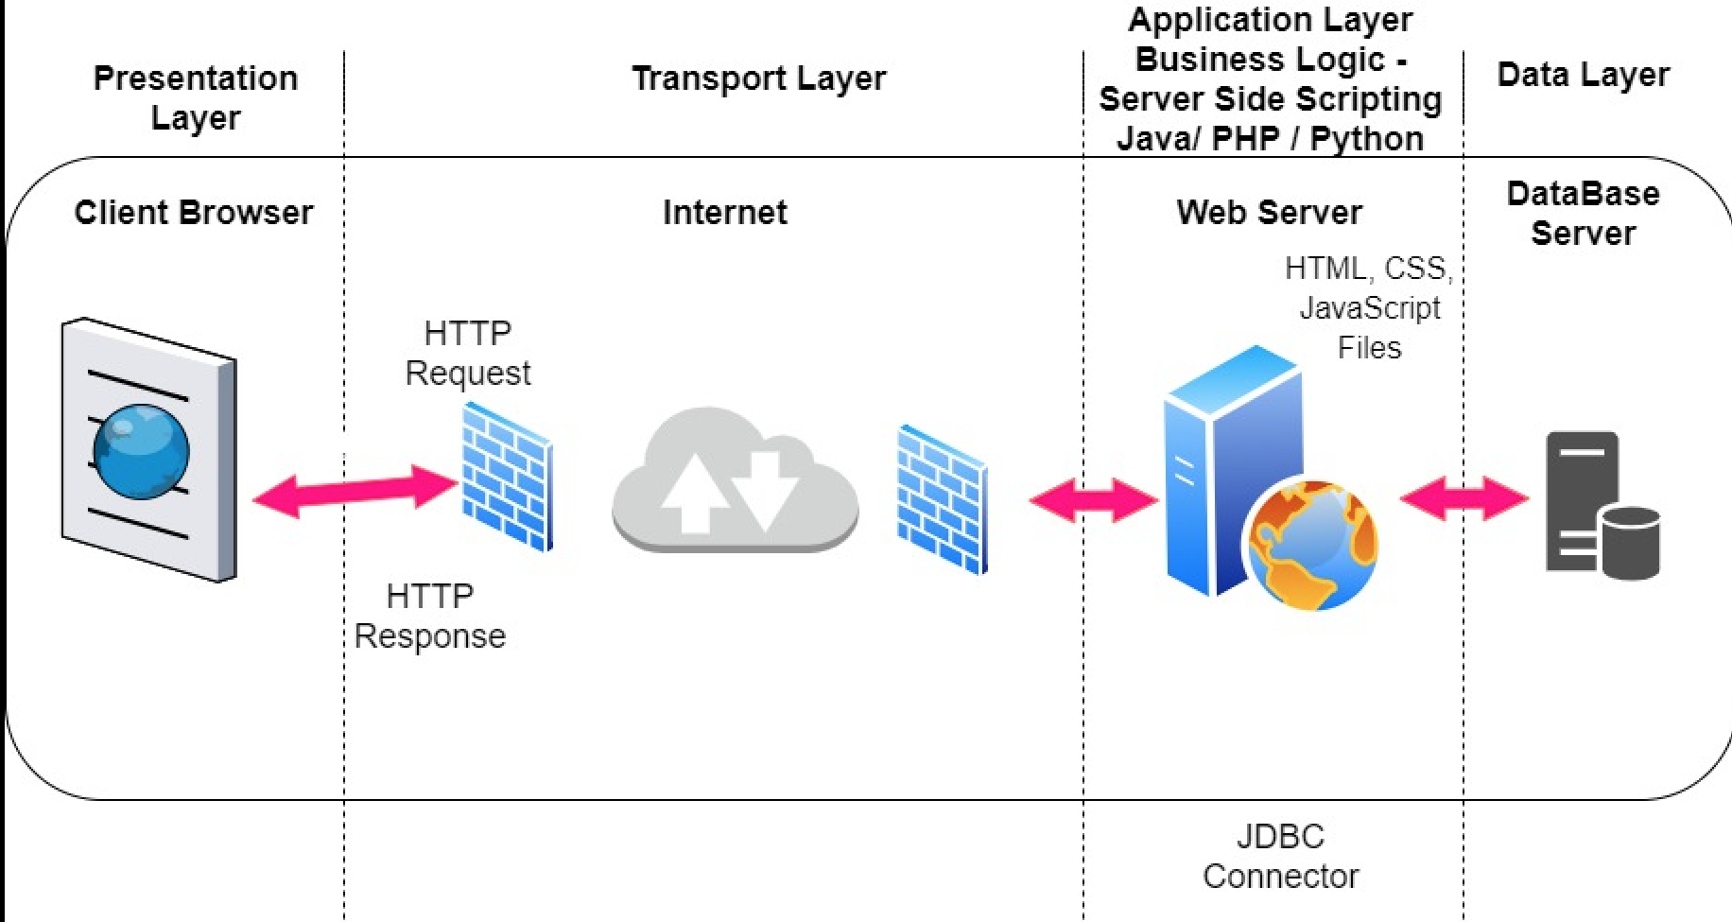

Case diagram
Activity diagram Register
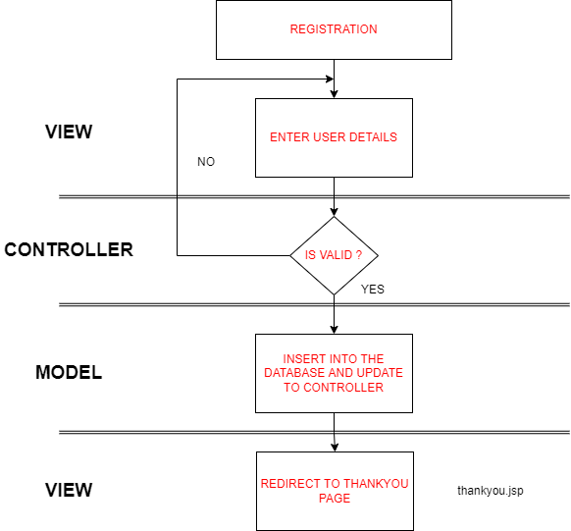
Activity diagram Login
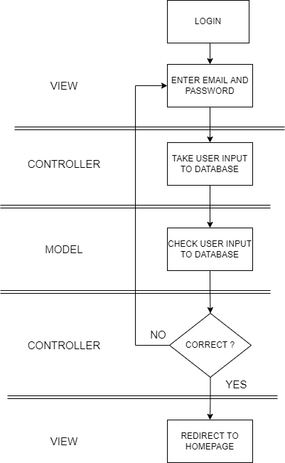
Activity diagram Forget Password
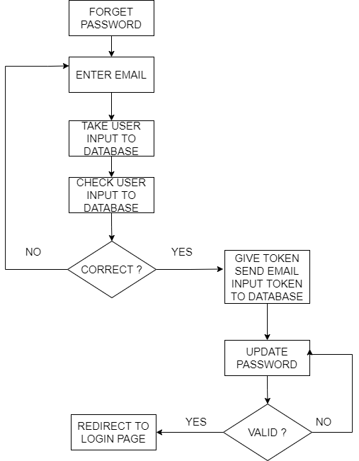

Activity diagram Search

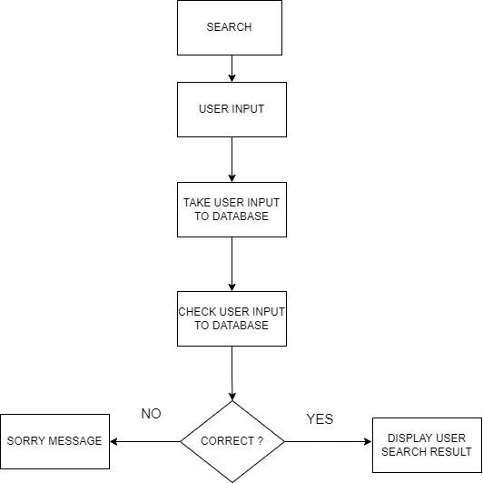
Activity diagram Update profile
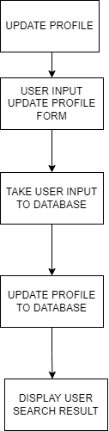

Task Statement (b): Architecture of the system
Solution:
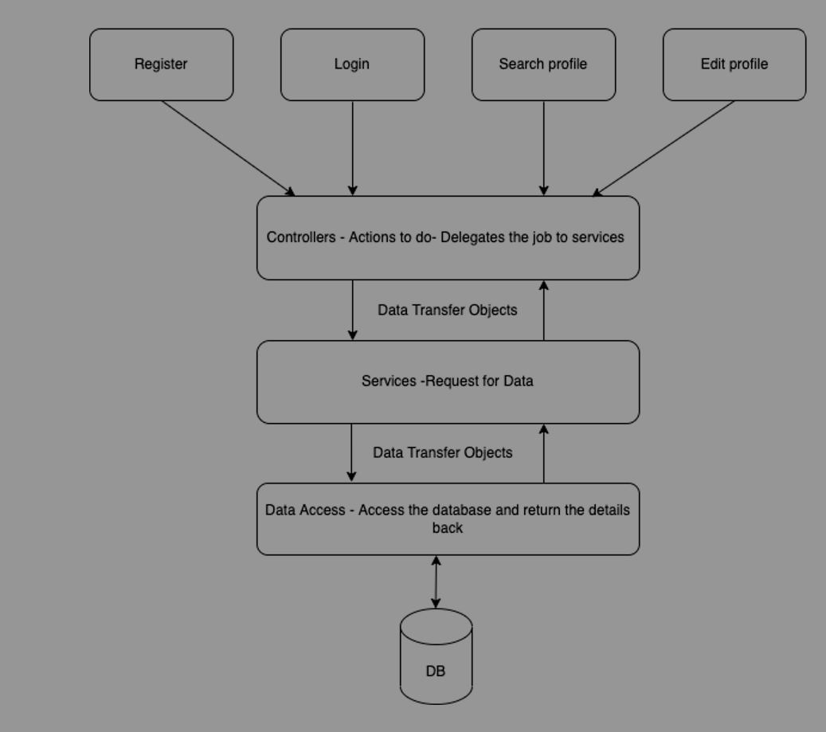
Step 1 − The client browser sends request to the MVC Application.
Step 2 – Application receives this request and performs routing based on the URL of the incoming request
Step 3 − This routing operation calls the appropriate controller and executes it
Step 4 − The Controller request the data using Model and execute the appropriate service
Step 5 – Database respond the service by giving an appropriate data
Step 6 – The required data displayed on the view
- System
  - List down all the modules to be developed
- Private Module - Administrator - Manage user Data and Bulk Emailing.
- Public Module - Software Programmers – Update profile adn find other user
  - List down all the pages in each of the modules and briefly describe the purpose
- Private Module - Administrator
  - Admin-dashboard, display user list
  - Admin add user, form to add new user
  - Admin edit user, form to edit user data
  - Admin profile, display admin profile
- Public Module - Software Programmers
  - Search, search other user by input first or last name
  - Search-result, display list user have searched
  - someoneProfile, display other user profile
  - Profile, display user profile
  - UpdateProfile, contain update user form
  - Note down which are Create, Edit & View pages.
- Insert - Create Page for users to register and data are inserted into database
  - Register
  - Add user
- Select - View Page for the users can view the others profile page
  - Search result
- Update - Update Page for the user to edit and update their profile page
  - Update user
  - Edit
  - New password
Module | Pages | Brief description | Operations
Common | footer.jsp | Copyright, company name, privacy policy and sitemap | View
Common | header1.jsp | Logo, Hyperlink | View
Common | header2.jsp | Logo, Hyperlink | View
Common | headerAdmin.jsp | Logo, dropdown | View
Common | Index.jsp | Navigation, footer, Banner, Testimony | View
Common | Homepage.jsp | Navigation, footer, Banner | View
Common | Register.jsp | Navigation, footer, register form | View
Common | Confirm.jsp | Navigation, footer, Confirmation message | View
Common | Reset-password-form.jsp | Navigation, footer, Forget password form | View
Common | Reset-password-confirm.jsp | Navigation, footer, forget password confirmation | View
Common | Login.jsp | Navigation, footer, login form | View
Common | Filenotfound.jsp | Navigation, footer, image | View
Public | Search-result.jsp | Navigation, footer, user list | View
Public | Userprofile.jsp | Navigation, footer, user profile detail, update profile | View
Public | someoneprofile.jsp | Navigation, footer, user profile detail | View
Public | Editprofile.jsp | Navigation, footer, update user form | View
Private | Admin-dashboard | Navigation, footer, list user, edit, delete, add user | View
Private | Admin-add | Navigation, footer, new user form | View
Private | Admin-edit | Navigation, footer,edit user form | View
Private | Admin-profile | Navigation, footer, admin profile detail | View

  - Create the Sitemap of Public & Private Site

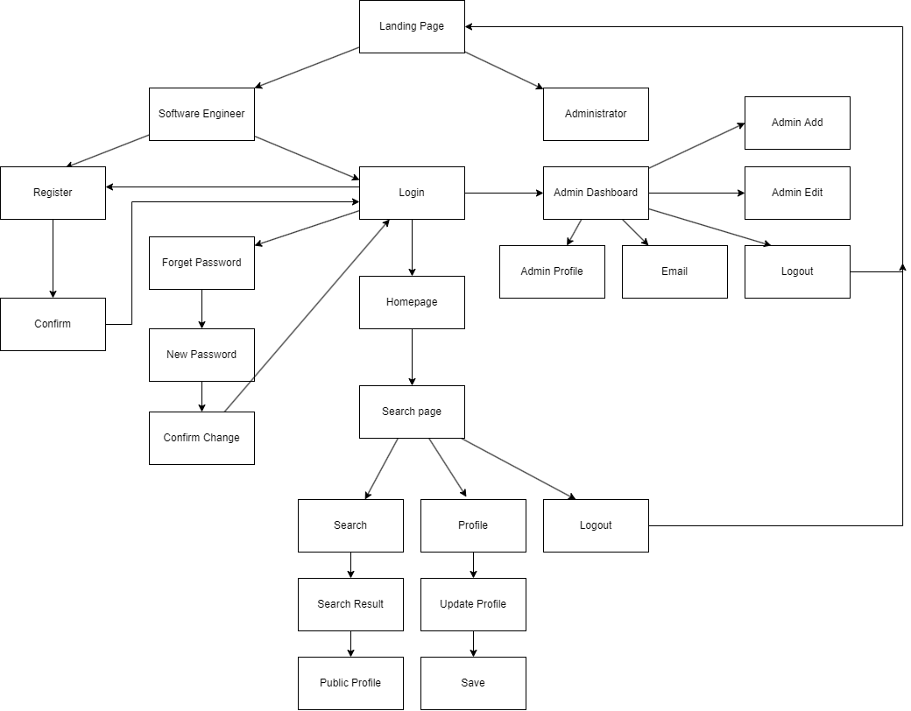

- Technical Environment Requirements
Hardware Requirements
- Database server – MySQL server
- Firewall settings - Port 8080 -- Http
- Port 3306 – Database
Software Requirements
Development environment- Java 17
Framework Spring 5
Database server- MySQL Server
- System Integration Requirements
MySql - MySql Connector 8.0.30
- Portability Requirements
Multi OS- Windows, Linux, and Mac
Multiple Browsers - Chrome, Firefox
Multiple Devices - Desktop, Tablet, Mobile
- Maintainability Requirements
      - Backup the database for every 6 hours.
      - Vulnerability check – periodical scanning.
      - Each request should be processed with 10 seconds.
- Performance Requirements
Concurrent number of users- 50
Loading time – 25secs
- Security Requirements
- List down the Security Access for the different kind of users
- User have their own email & password Different from other users.
- User also have role constants to differentiate between Sofware Engineer and Administator

- Briefly explain Login & Logout mechanism
- Login
When user enter their email & password the application do checking if the email password is valid and check role of the user registered in database. If the user are exist in database user will get a HttpSession when login and directed to apropriate page based on role

- Log out
The HttpSession will be terminated and user will be back to landing page
Task 2
Task Statement:
- Provide Screen capture of eclipse IDE
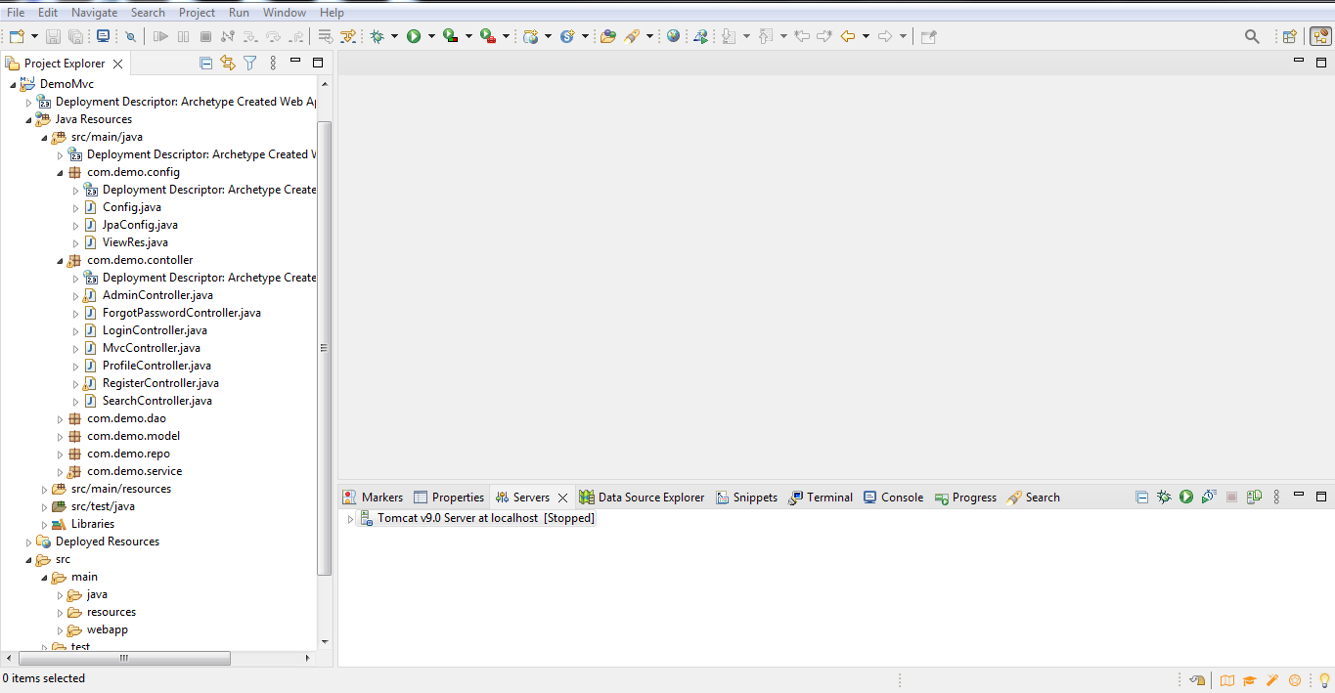

- Task 3

Task Statement:
- Provide description of 3 features in IDE along with the screen capture of their use.
Three IDE features are
- Debuging
The Eclipse Java IDE provides many debugging tools and views grouped in the Debug Perspective to developers debug effectively. It allows developers to easily set breakpoints, start and stop the running application, or perform various debugging activities.In most cases, developers can edit and save the code while debugging without restarting the program.
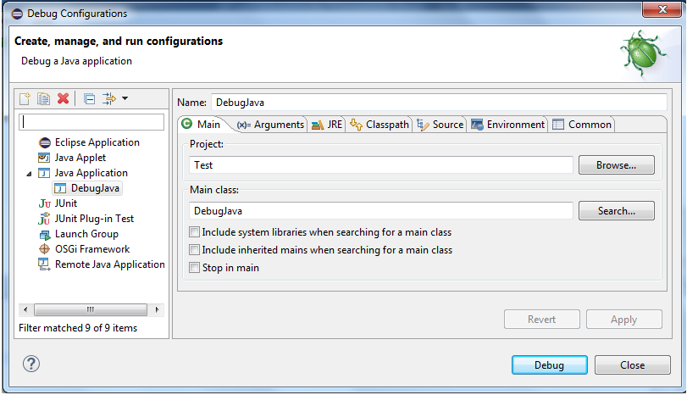
- Local History
Allows you to retrieve and store source code. Every time you modify a file, a copy of the old contents is stored in the local history. You can compare or replace a file with any older version from the history at any time. Although this is no replacement for a real code repository, it can help you out when you change or accidentally delete a file.
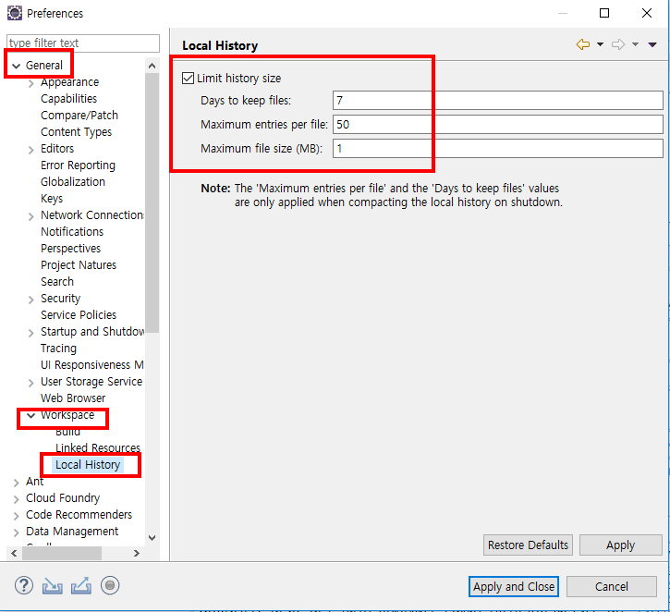
- Code Insight
The identification of functions and keywords for any specific programming language is a vital part of any kind of IDE platform. The plug-ins are available for each programming language in the Eclipse IDE so it is easy to identify the keywords and build apps on this platform
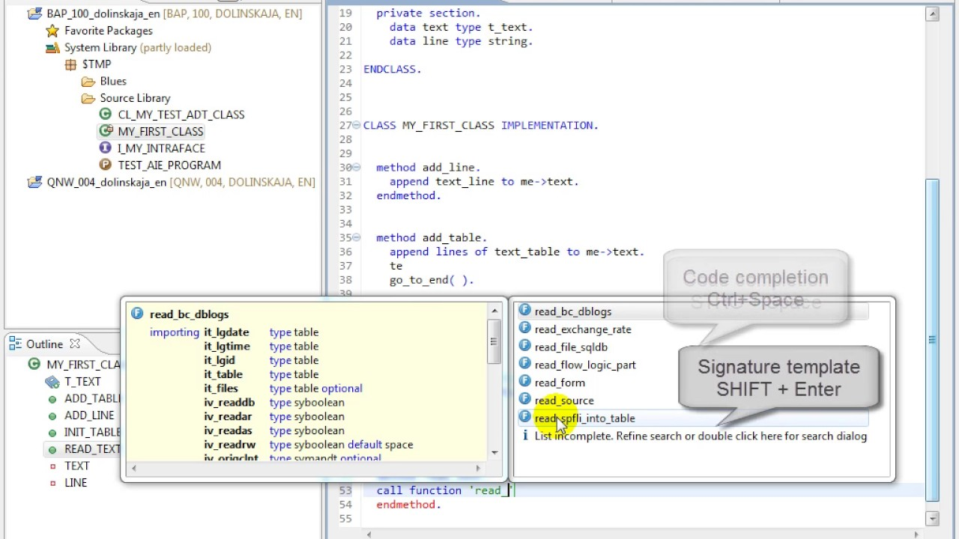
- Include it as part of Project Presentation

- Task 4

Task Statement
Create the following items in “Coding & Documentation Standards” Section in Project Report
- List 5 Coding Standards & Conventions to be used and explain shortly.

- Naming Convention
Class Name - Class names should be nouns, in mixed case with the first letter of each internal word capitalized.
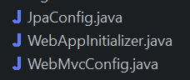

- Indentation
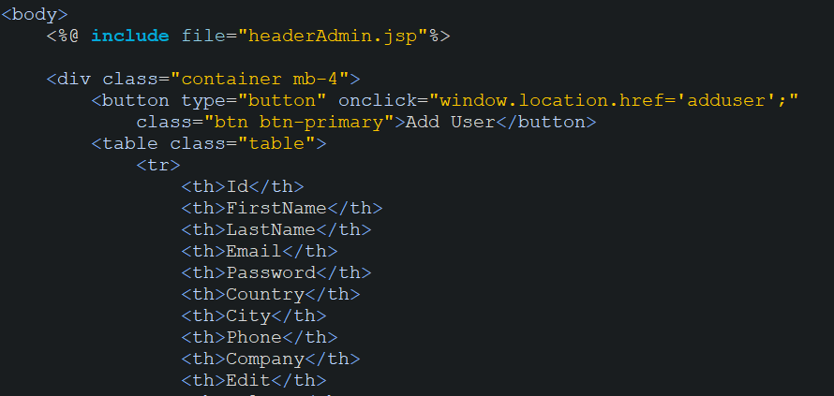
- Error return values and exception handling conventions
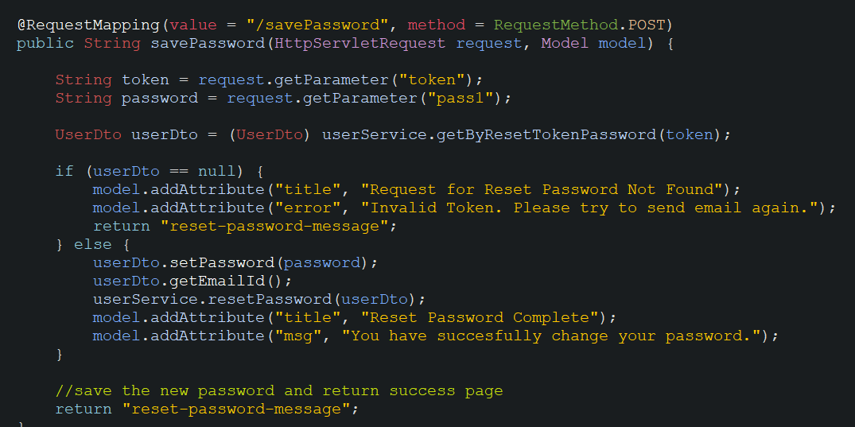

- Avoid using an identifier for multiple purposes:
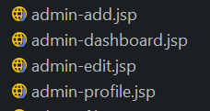
- using a coding style that is not too difficult to understand
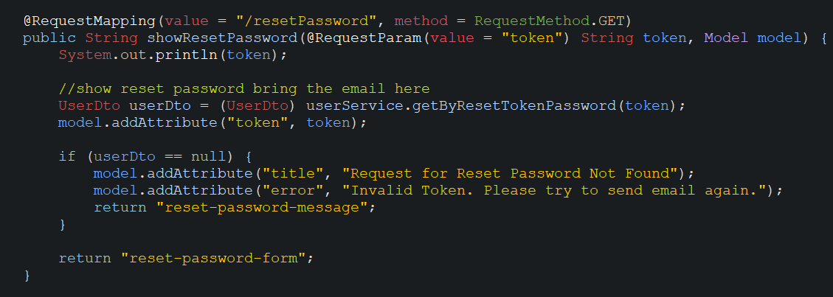
- Describe briefly documentation tool, you will be using and its configuration.

Solution
Go to Project -> Generate Java Doc ->choose the location of Javadoc->finish.
Generate the doc file in the desired location.
- Task 5 (Views)

Task Statement
- Develop the following pages in HTML (Developed in Module 3) (source code)
  - Home Page
  - Update Page
  - Listing Page
  - Login/Logout
  - Forget Password screen
  - Administration Page

- Template them by separating Headers/ Footers and including them using Server Side includes.
(header.jsp and footer.jsp) (include)
- Provide the screen capture in Project Presentation
Solution

- Task 6 (java classes)
- Package wise
- MainCotroller.java
Source code
Task Statement:
- Create the required classes in Java
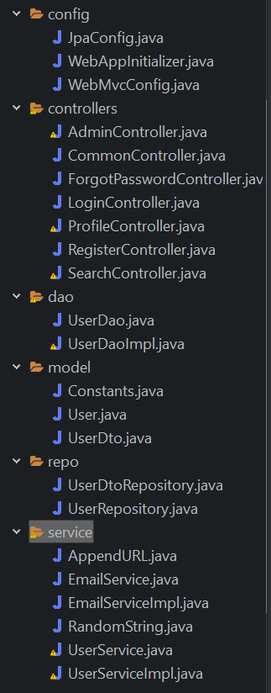
- Include samples as part of Project Report

- Task 7
(screen capture of your working website – web pages)
Task Statement:
Provide screen capture of developed pages and hosted application in Project Presentation
- Use Queries, Procs Developed in Module 4
- Develop the Models, Views, Controller (at least for one of the functionality, better if you can use for all the functionality)
- Develop Home Page & Integrate with Login System
- Develop Registration Form & Registration Thank You
- Develop Forget Password mechanism
- Develop Landing Page post login
- Develop Search Box for Users
- Develop View Search Results
- Develop View Profile Page
- Develop Edit Profile Functionality
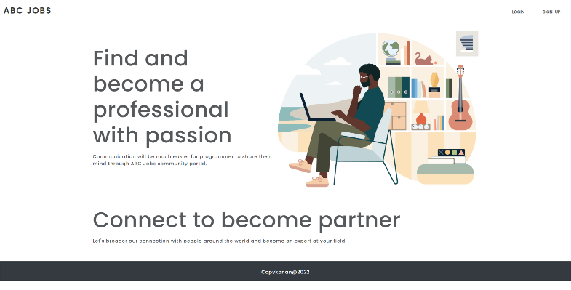
Solution


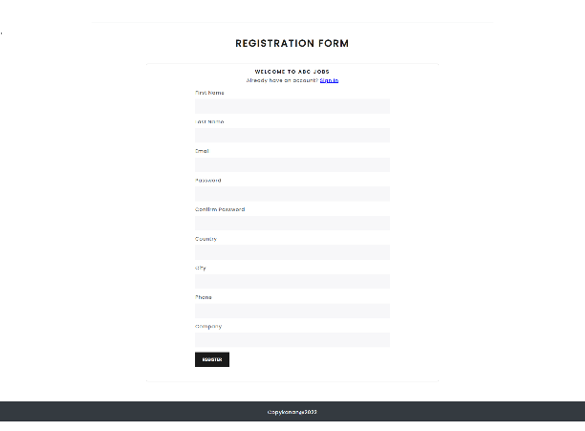

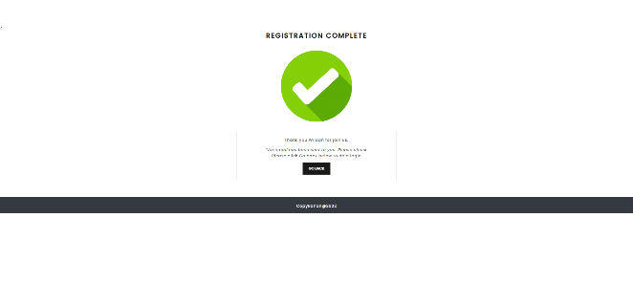
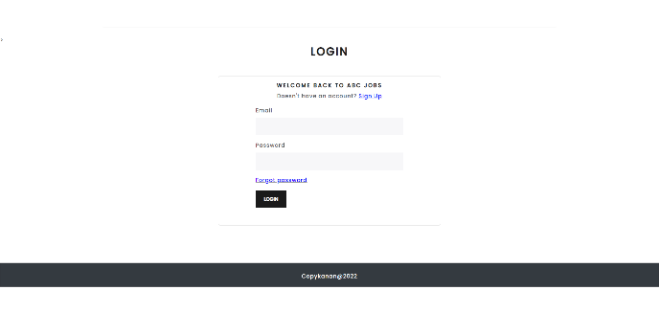

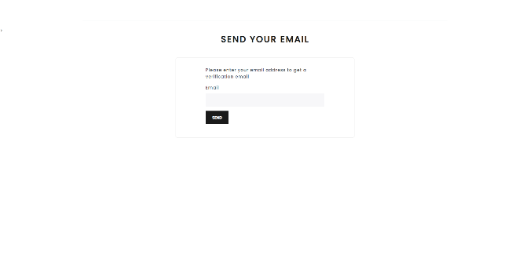
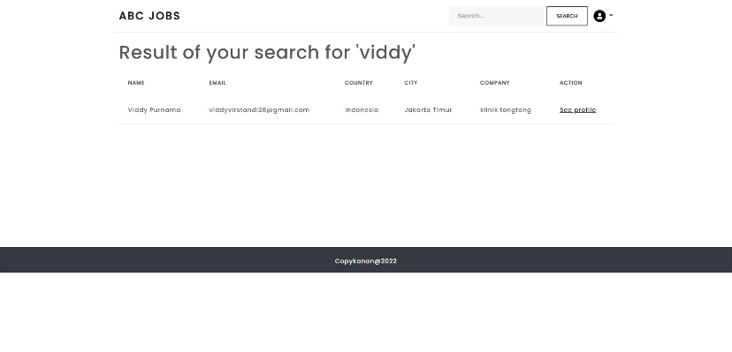

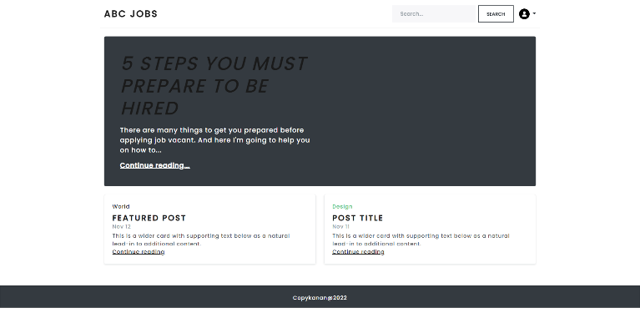
- Task 8

Task Statement:
- Debug the application in Eclipse
- Provide the screen capture of your application code in Eclipse Debug Mode include it as part of Project Presentation
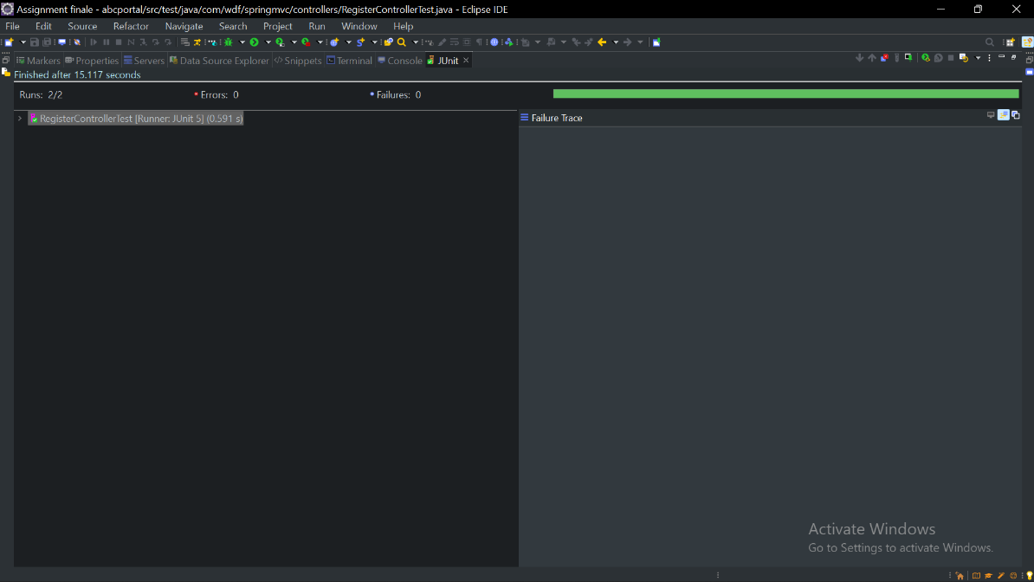

- Task 9

Task Statement:
- Provide screen capture of 3 Errors you encountered while developing the application.
- Include it as part of Project Presentation
Error | Error handling (Solution)
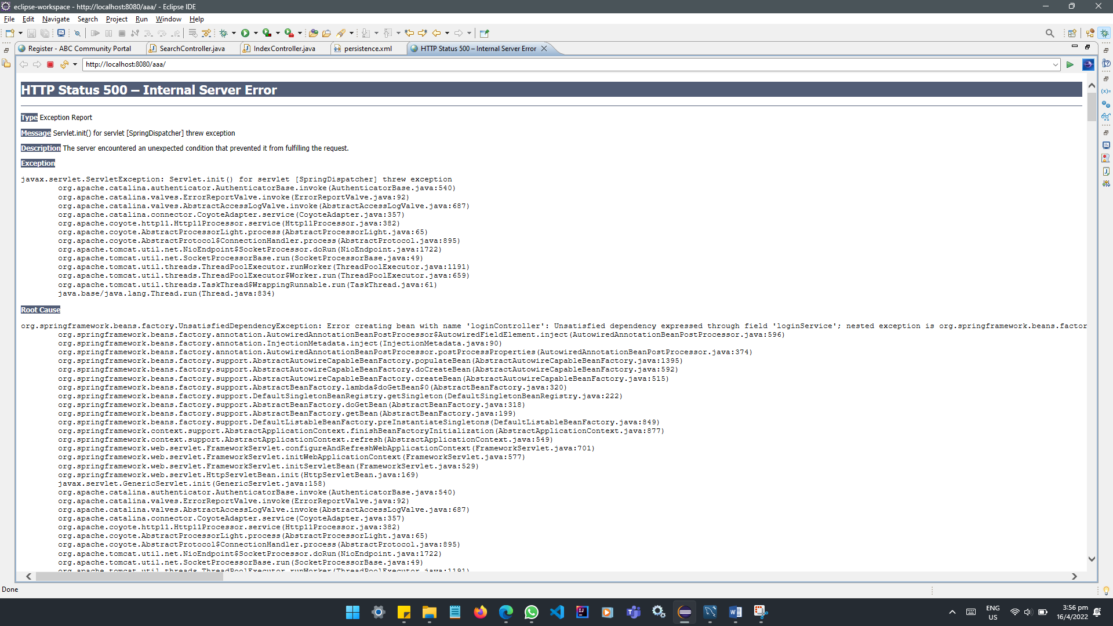 | - Look at HTTP Status  - Check out the Root Cause  - Look at the last sentence  - Unable to create requested service [org.hibernate.engine.jdbc.env.spi.JdbcEnvironment]  - Likely caused by JDBC or repository interfaces  - Check persistence.xml  - Fixed jdbc:mysql://localhost:5306 to jdbc:mysql://localhost:3306
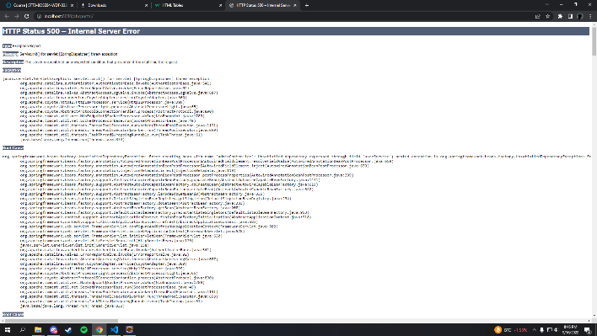 | - Look at HTTP Status  - Check out the Root Cause  - Look at the last sentence  - Unable to create requested service [org.hibernate.engine.jdbc.env.spi.JdbcEnvironment]  - Likely caused by JDBC or repository interfaces  - Check persistence.xml  - Add schema name (because I forgot to add it)
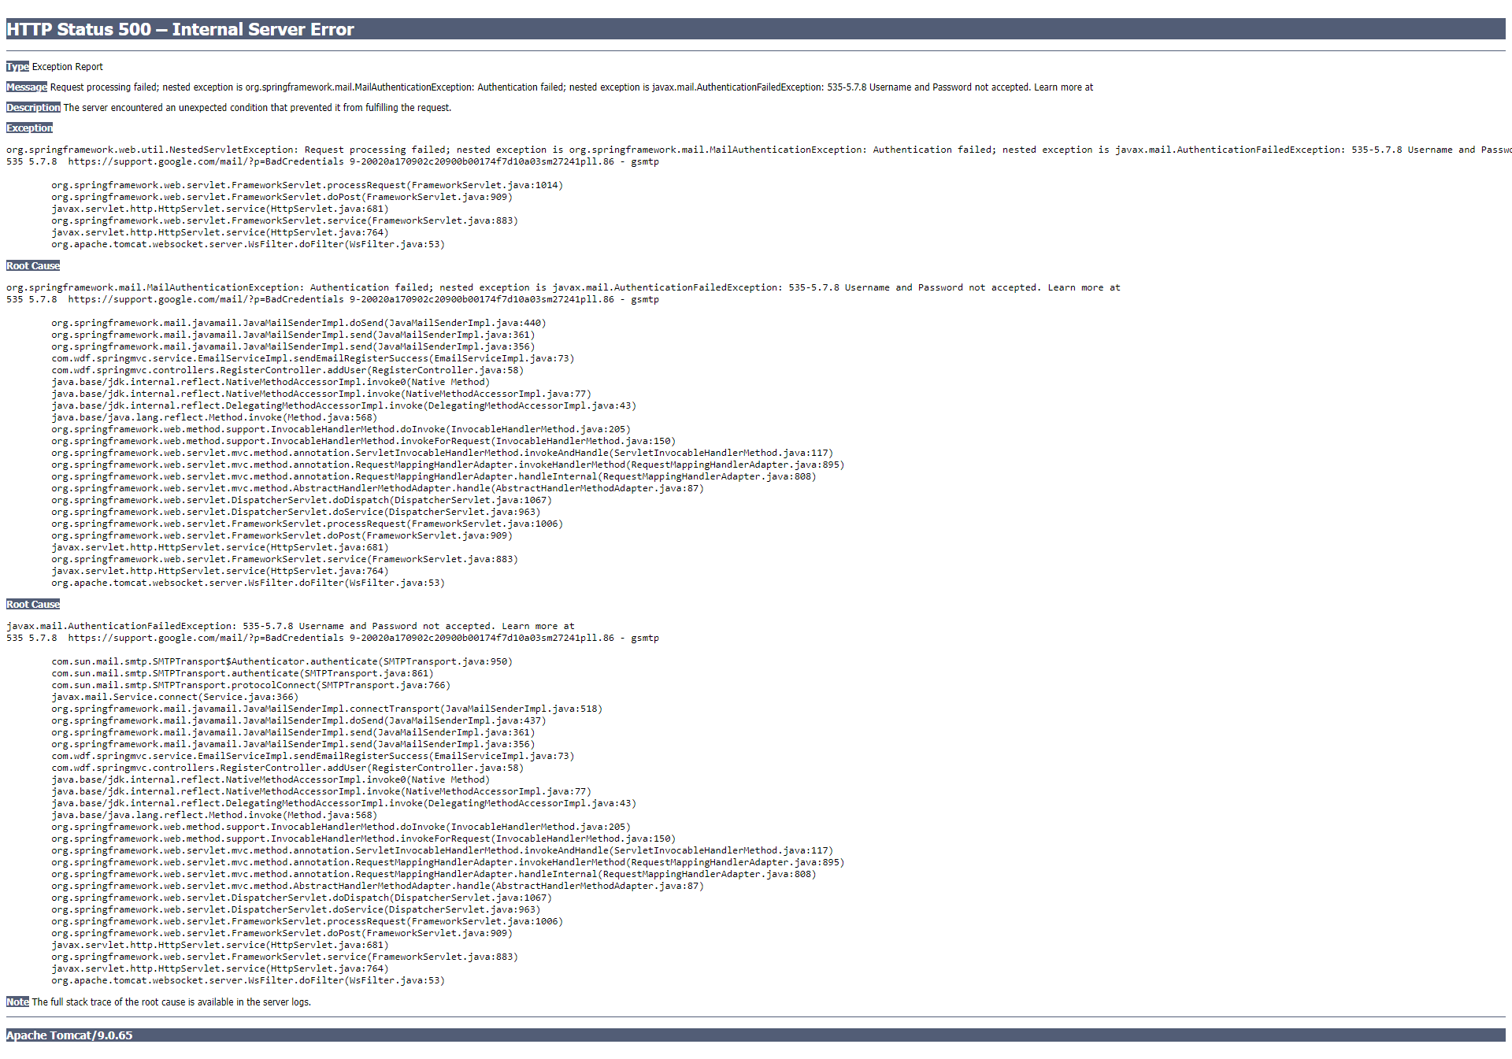 | - Look at HTTP Status  - Check out the Root Cause  - Look at the last sentence  - Username and Password not accepted.  - Likely caused by wrong password input at email.properties  - Check email.properties  - Change password from email password to app password

- Task 10

Task Statement:
- Propose & Document a New feature to the application
Before : ABC jobs can’t send registration-thankyou email
After : ABC Jobs can send registration-thankyou email
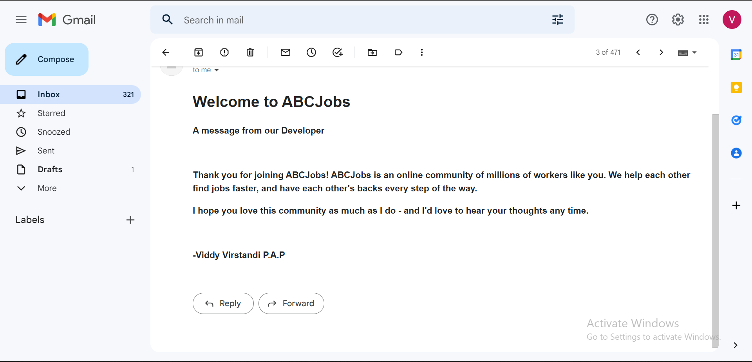

Before : ABC Jobs can’t do search another user
After : ABC Jobs can do search another user
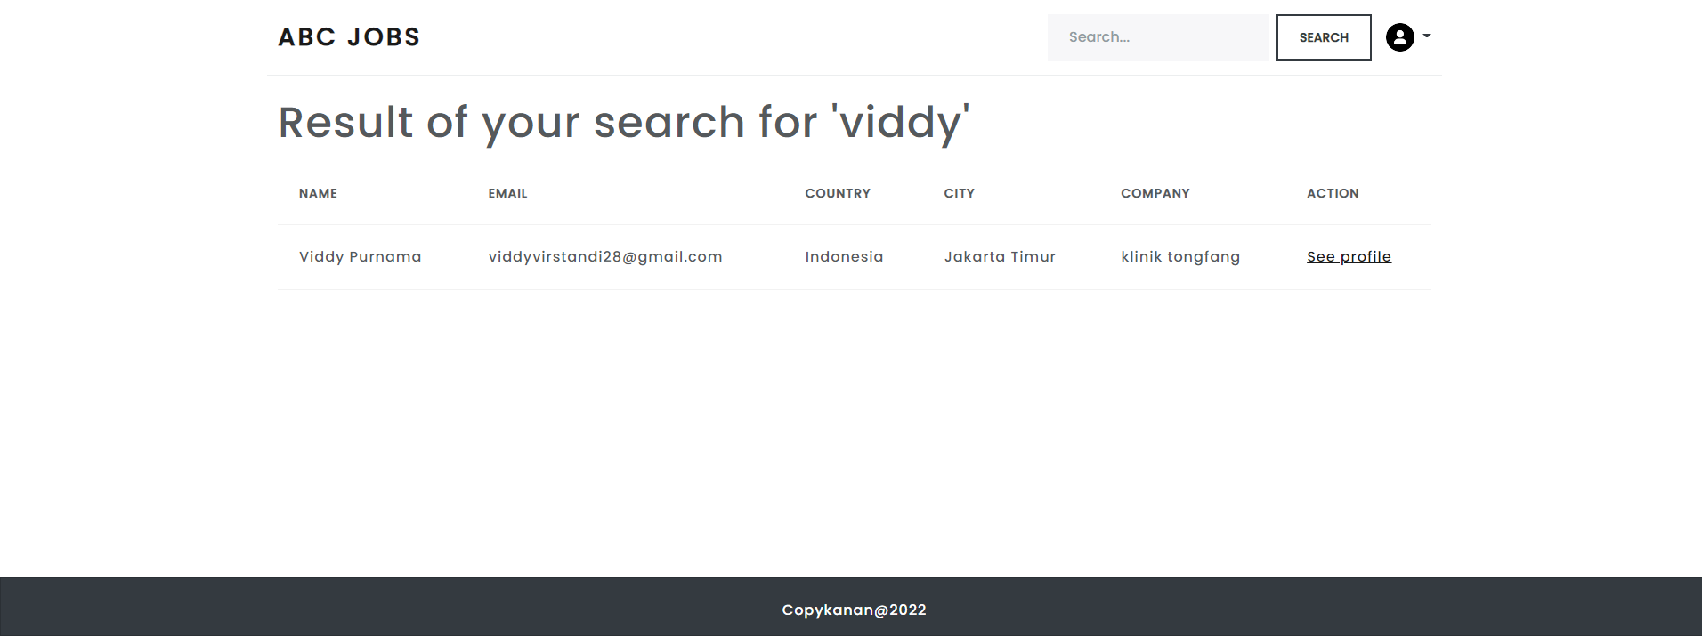
- Develop the new feature and provide a report.
- Include it as part of Project Report

- Task 11

Task Statement:
Provide Unit Testing code & screen capture of Eclipse IDE in debug mode.

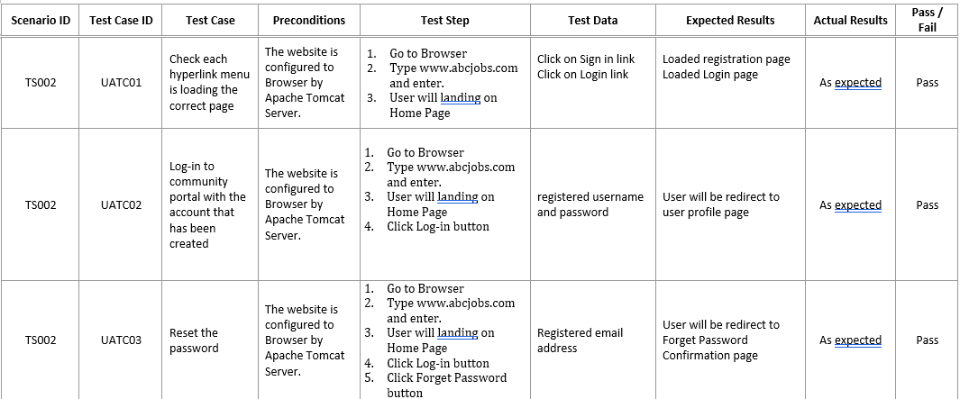
homepage

